CHANGING THE POLITICAL AND RELIGIOUS COLORS OF THE UNITED STATES

Dr. Alberto R. Treiyer

Recently, Fox News commentator Tucker Carlson dared to unmask the immigration policy of the current U.S. government. He said, literally:

“When you change who votes, you change who wins. That fact has nothing inherently to do with race or nationality. It’s the nature of democracy.” “Demographic change is the key to … political ambitions. In order to win and maintain power,” the current government “plan to change the population of the country. They’re no longer trying to win you over with their program. They’re obviously not trying to improve your life. They don’t even really care about your vote anymore. Their goal is to make you irrelevant.” [https://www.foxnews.com/opinion/tucker-carlson-immigration-demographic-change-democrats-elections].

That policy is not new. The Assyrian kings took most of the ten tribes of northern Israel captive, and brought peoples from other countries to take their place. The story is found in 2 Kings 17. In modern times, Adolf Hitler resorted to the same method when he tried to fill Poland with millions of German immigrants but went further still. He wanted to empty Poland, Belarus and Ukraine of the millions of nationalist people who lived there, giving their houses and properties to German immigrants. [https://en.wikipedia.org/wiki/Expulsion_of_Poles_by_Nazi_Germany].

When millions of Jews wanted to emigrate from the ethnic cleansing of Nazism in Germany, major countries, including the U.S., refused to give them a mass reception, fearing that in time they would lose their right to govern themselves under Christian principles. That led the German Führer to the Final Solution, their total extermination. The Holocaust Museum in Washington, DC documents that fact.

A religious strategy

The immigration plan of the new U.S. government goes beyond the attempt to perpetuate the actual ruling party. It seeks to attract millions of illegal immigrants to whom it promises even greater benefits than it gives its own citizens. Tucker Carlson warned that such immigration policy seeks to change the political color of the states to perennially dominate the population. But he didn’t dare admit the reality that this is only a half-truth. No one wants to expose the religious intent of a Catholic president who supports Pope Francis’ agenda on climate change to gain control of the world. Joe Biden is also wanting to change America’s image as a Protestant country. The purpose is to bring about a change in the system of government. He seeks not only a political dominance more akin with the Marxist left, but also with socialist Catholic morality to impose the supremacy of the papacy.

Behind the veil can be seen the same policy that the papacy exerted to awaken the jealousy of the rulers against Protestant growth in Europe. Here we will mention two quotes from the Spirit of Prophecy about this policy of Rome.

“Rome was not slow to inflame their jealous fears. Said the pope to the regent of France in 1525: ‘This mania [Protestantism] will not only confound and destroy religion, but all principalities, nobility, laws, orders, and ranks besides.’ (G. de Felice, History of the Protestants of France, b. 1, ch. 2, par. 8. A few years later a papal nuncio warned the king: ‘Sire, be not deceived. The Protestants will upset all civil as well as religious order … The throne is in as much danger as the altar … The introduction of a new religion must necessarily introduce a new government’ (D’Aubigne, History of the Reformation in Europe in the Time of Calvin, b. 2, ch. 36;” GC 277).

Statistics

Although the polls vary according to the companies investigating the religious representation in America, the most recent ones show a greater deterioration of Protestantism than that of Catholicism, and a growth in atheism. [https://www.pewforum.org/2019/10/17/in-u-s-decline-of-christianity-continues-at-rapid-pace/]. [https://news.gallup.com/opinion/polling-matters/235208/things-know-evangelicals-america.aspx]. The easiest way to overcome Protestantism is by attracting millions of immigrants from Catholic countries to a Protestant country. With a change in demographics, political and religious colors are likewise changed.

“Twenty-five years ago, nearly nine in ten (87%) Catholics were white, non-Hispanic, compared to 55% today. Fewer than four in ten (36%) Catholics under the age of 30 are white, non-Hispanic; 52% are Hispanic.” [https://www.prri.org/research/american-religious-landscape-christian-religiously-unaffiliated/].

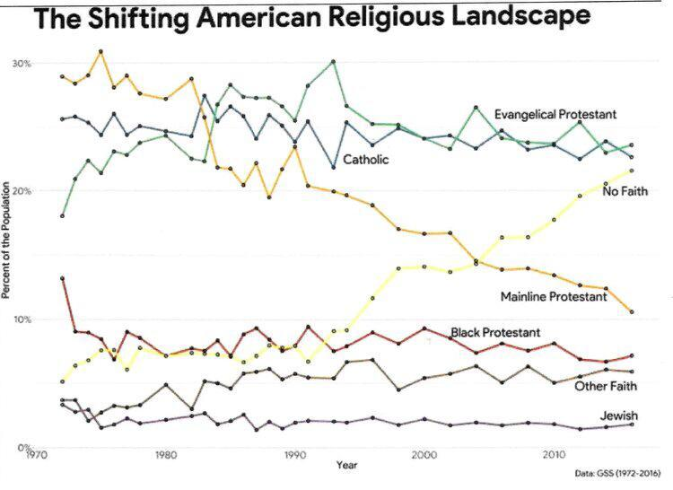

Some key statements of the Spirit of Prophecy

Let us draw some key points from the statements of the Spirit of Prophecy concerning the role of the USA in the final crisis.

“When … our country shall repudiate every principle of its Constitution as a Protestant and Republican government and shall make provision for the propagation of papal falsehoods and delusions, then we may know that the time has come for the marvelous working of Satan and that the end is near” (5 T 451 (1885)).

“The people of the United States have been a favored people, but when they restrict religious liberty, surrender Protestantism, and give countenance to popery, the measure of their guilt will be full, and ‘national apostasy’ will be registered in the books of heaven” (RH May 2, 1893).

“Roman Catholic principles will be taken under the care and protection of the state. This national apostasy will speedily be followed by national ruin. (RH June 15, 1897).

Methodology

The method that is being used to change the political and religious colors of the U.S. is that of promoting the “woke” culture. What is the “woke” culture? It promotes unrest regarding immigration policy, race and gender identity, promoting hatred by the poor against what they consider white supremacy. Tucker Carlson warned that no one wants to talk about the true purpose of those who promote “woke” hatred. No one can talk about the moral problems of gender identity changes because they are condemned as homophobic, etc. In this way, new political and religious principles are imposed over all criticism and opposition, to rule the masses and destroy the true democracy and freedom of this country.

In a Fox News interview with Ben Carson on April 9, the famous black doctor said the divine slogan is, “love your neighbor.” But he added that the wokeism slogan is, “cancel your neighbor.” He also said that the more the government expands, the more individual freedoms are curtailed, because God is discarded in favor of the government. It implements hatred against white supremacy that allegedly discriminates against blacks, Asians, Hispanics, and those who deny their biological gender identity. But do those who raise that hate flag really love those people? You can’t love by hating others.

Conclusion

Immigration is good. And most countries of the world know it. In general, it seeks to attract the most capable and industrious people for the aggrandizement of the nation. But is that what you are looking for today with illegal immigration, regardless of the risks involved? There will be a lot of good, sincere and hard-working people among these immigrants. Still, should we not watch to hinder evil people from coming, who will eventually lead this country to ruin? Let us meditate on the following quotation that is based on the history of the Pilgrim Fathers, and their contribution to the formation of this country.

“As the tidings spread through the countries of Europe, of a land where every man might enjoy the fruit of his own labor and obey the convictions of his own conscience, thousands flocked to the shores of the New World. Colonies rapidly multiplied” (GC 296).

“Republicanism and Protestantism became the fundamental principles of the nation. These principles are the secret of its power and prosperity. The oppressed and downtrodden throughout Christendom have turned to this land with interest and hope. Millions have sought its shores, and the United States has risen to a place among the most powerful nations of the earth” (GC 441).

“But continually increasing numbers were attracted to the shores of America, actuated by motives widely different from those of the first Pilgrims. Though the primitive faith and purity exerted a widespread and molding power, yet its influence became less and less as the numbers increased of those who sought only worldly advantage” (GC 297).

